Day 2 - Jenkins - Configuration

Task : Create a simple project with Jenkins connected to your GitHub repository. When a commit is made to your repo, automatically build must get triggered from Jenkins and the output must be shared via email."

Create a simple project with Jenkins connected to your GitHub repository

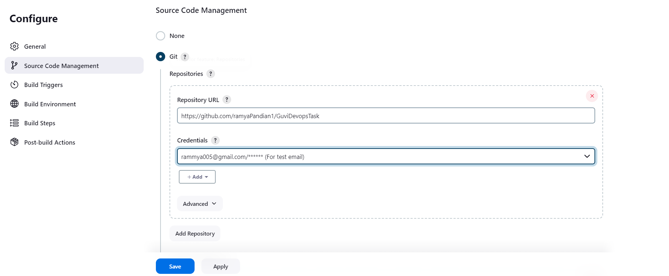

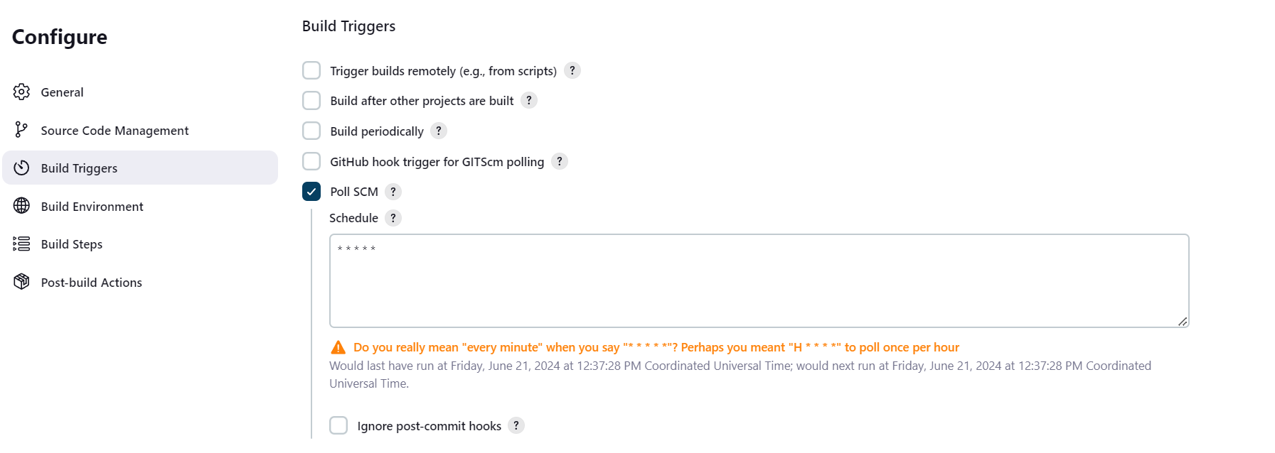

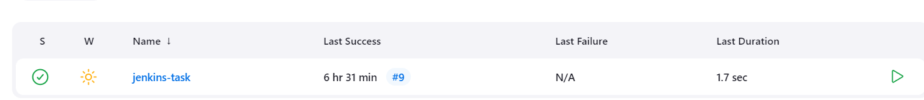

With e-mail notification was only able to send email in case of failure so I downloaded the plugin “extended email” to send email when success also

Email configuration from project

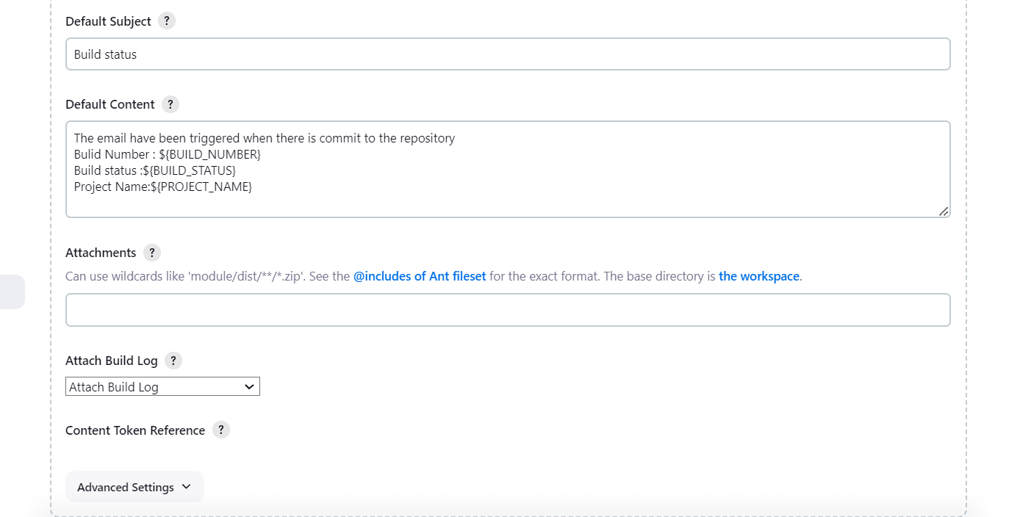

Email configuration from manage Jenkins

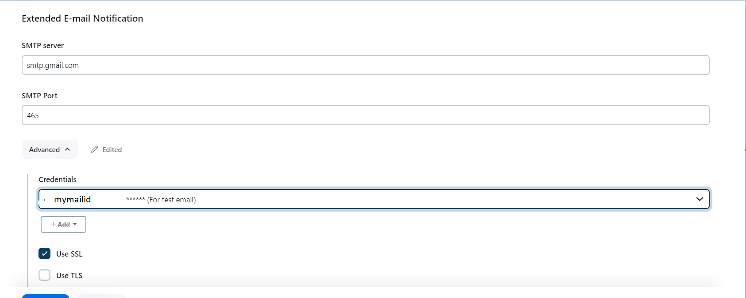

For email credentials in my mail settings created a app password and store that in credentials in Jenkins

Before committing the code to Jenkins there are 11 build

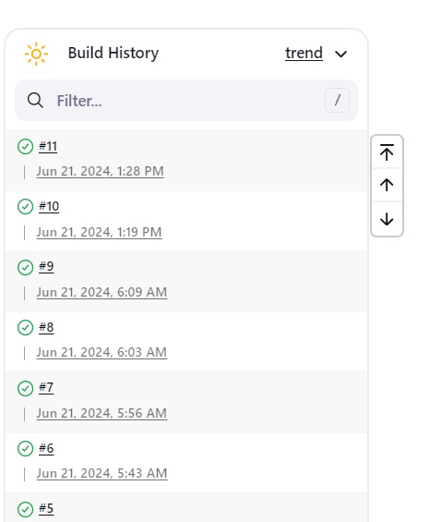

Creating a new file in github

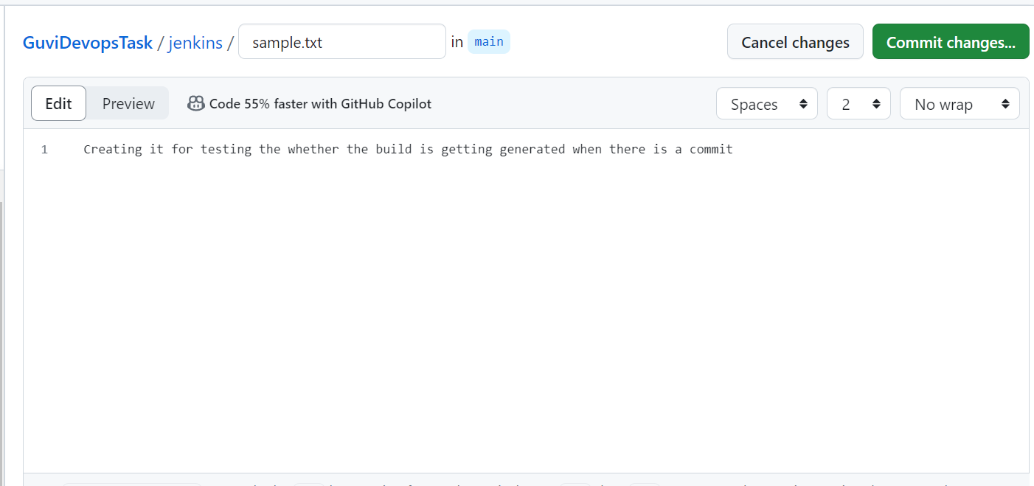

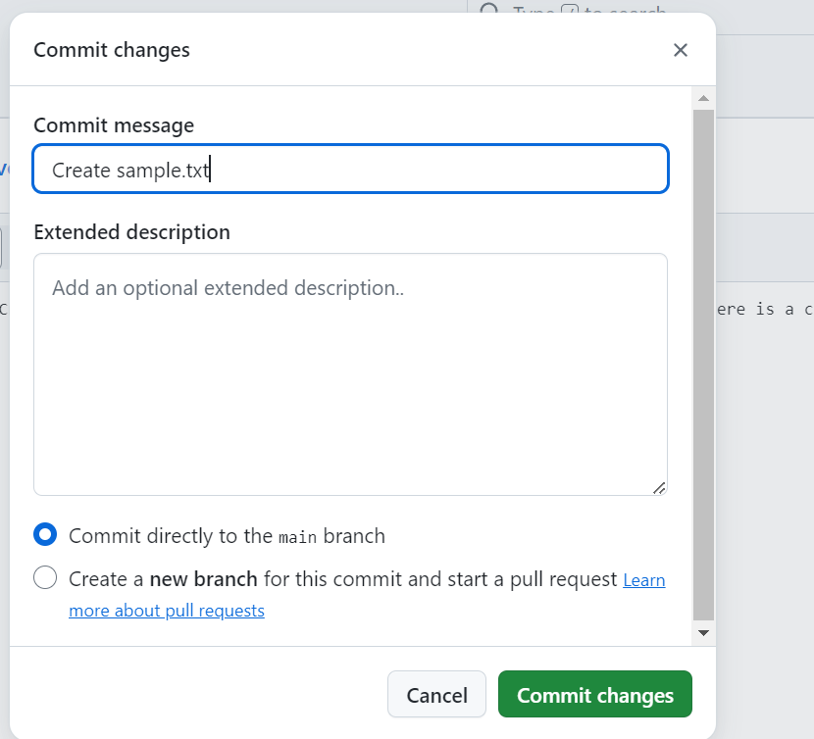

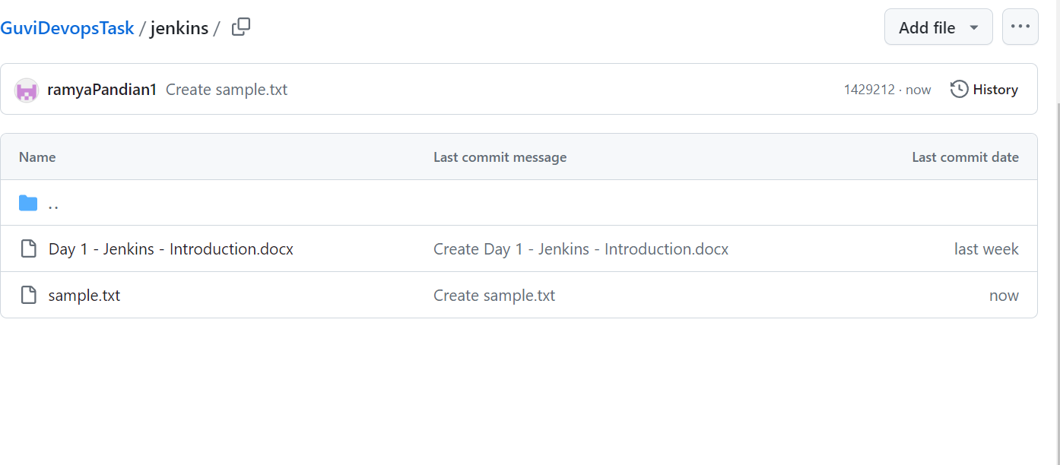

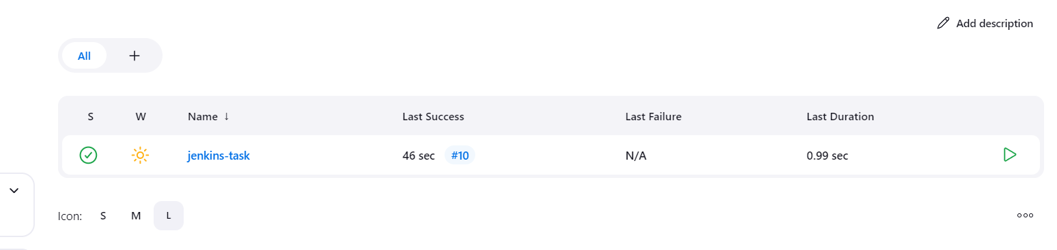

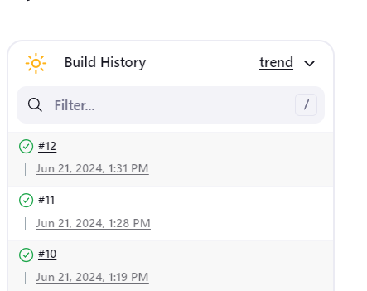

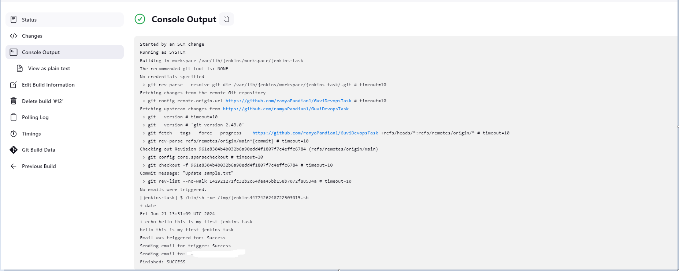

Attached build log to mail also printed status projectname and build number in email

